UI/UX Assignment#1
- Sign In Flow
ebay.com
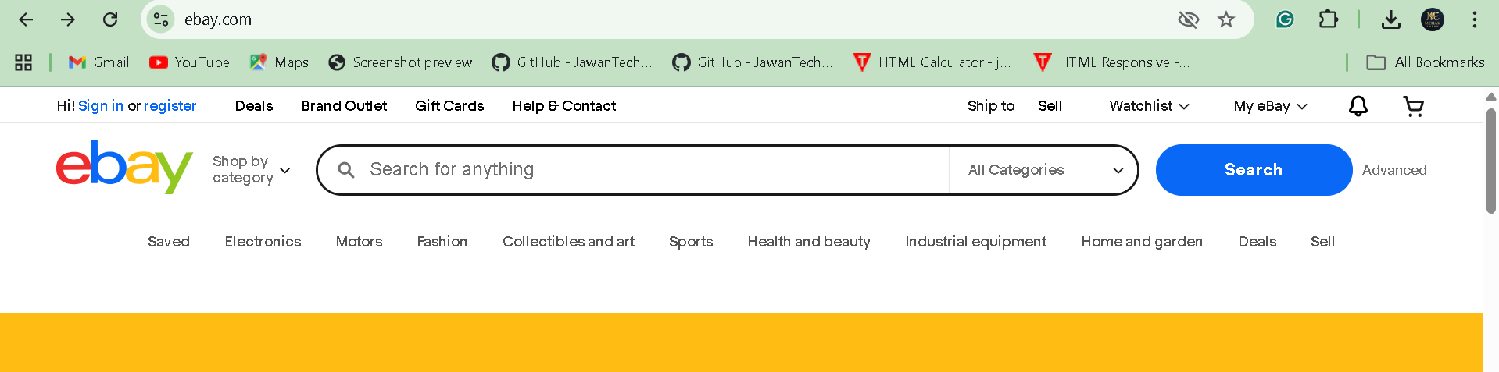

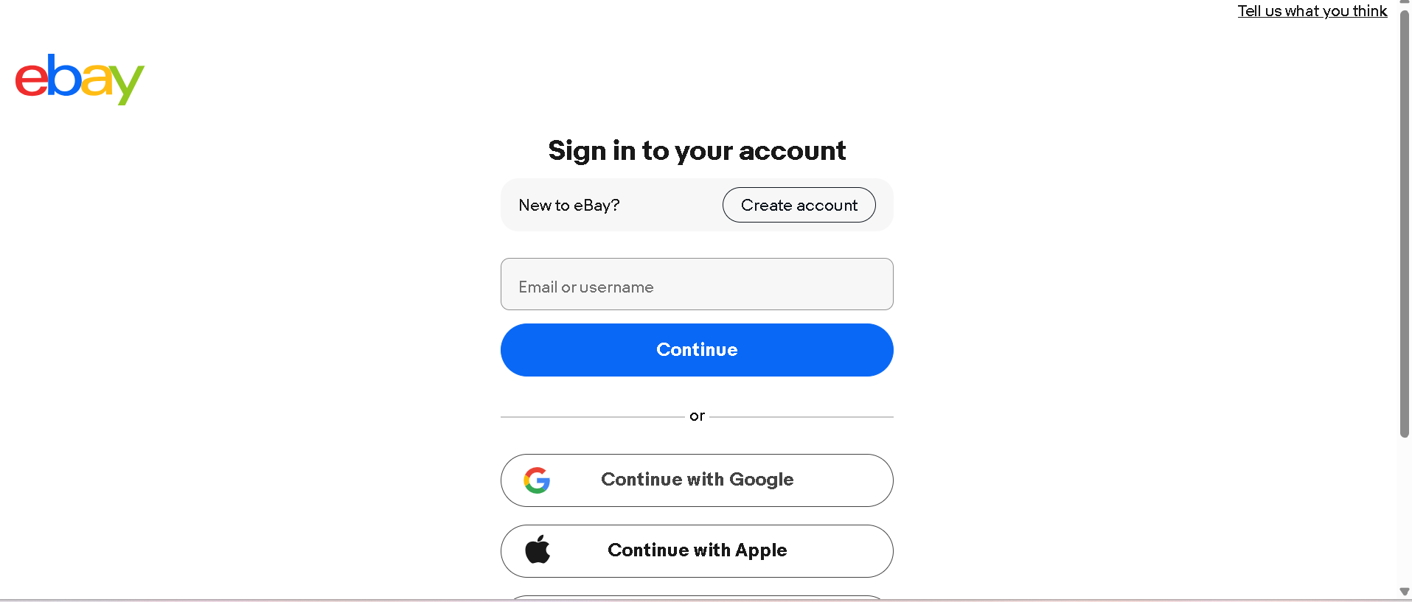
the sign in is almost similar.

Amazon.com
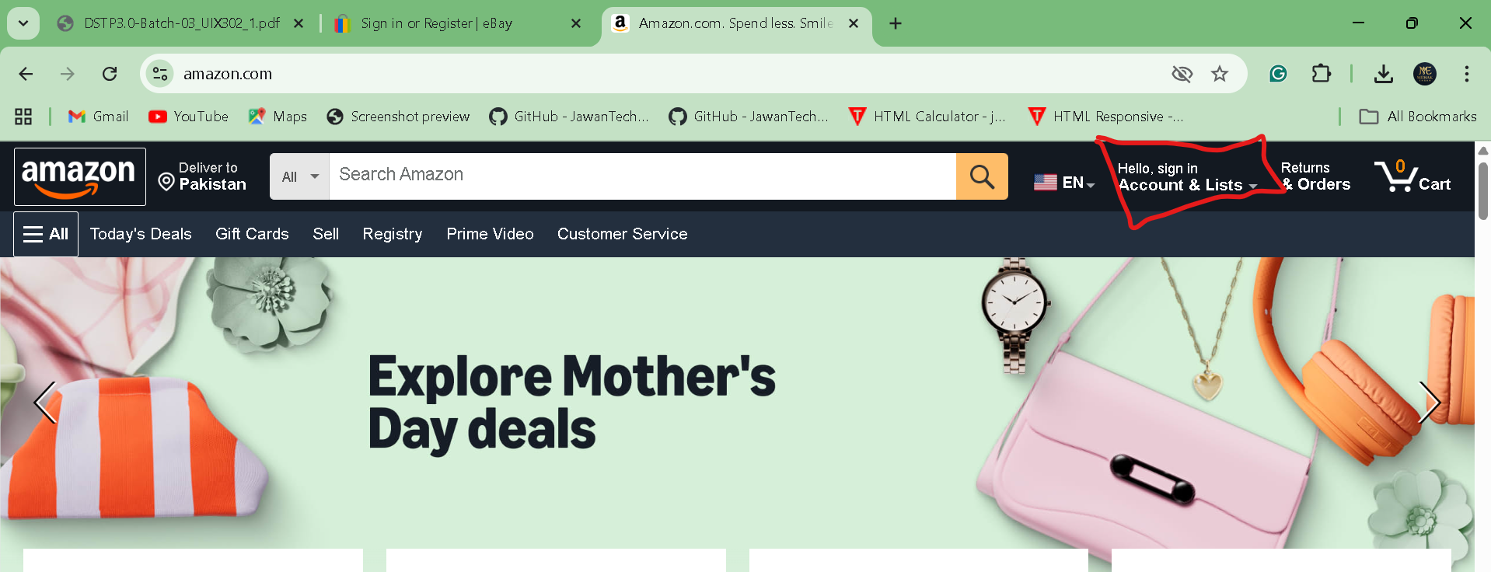

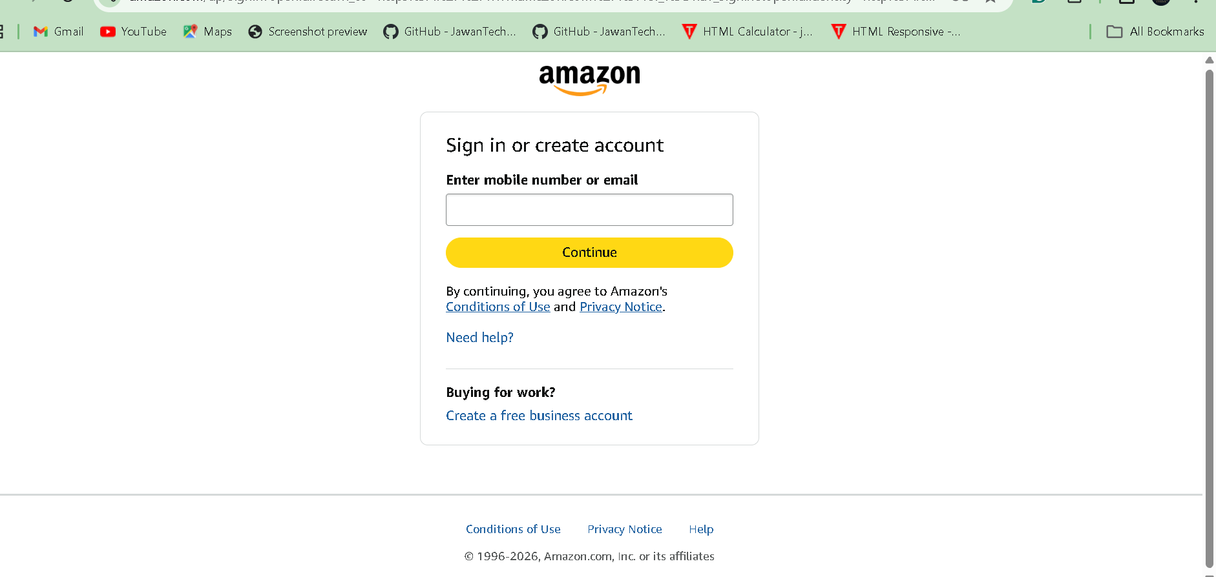

- Navigation Bars

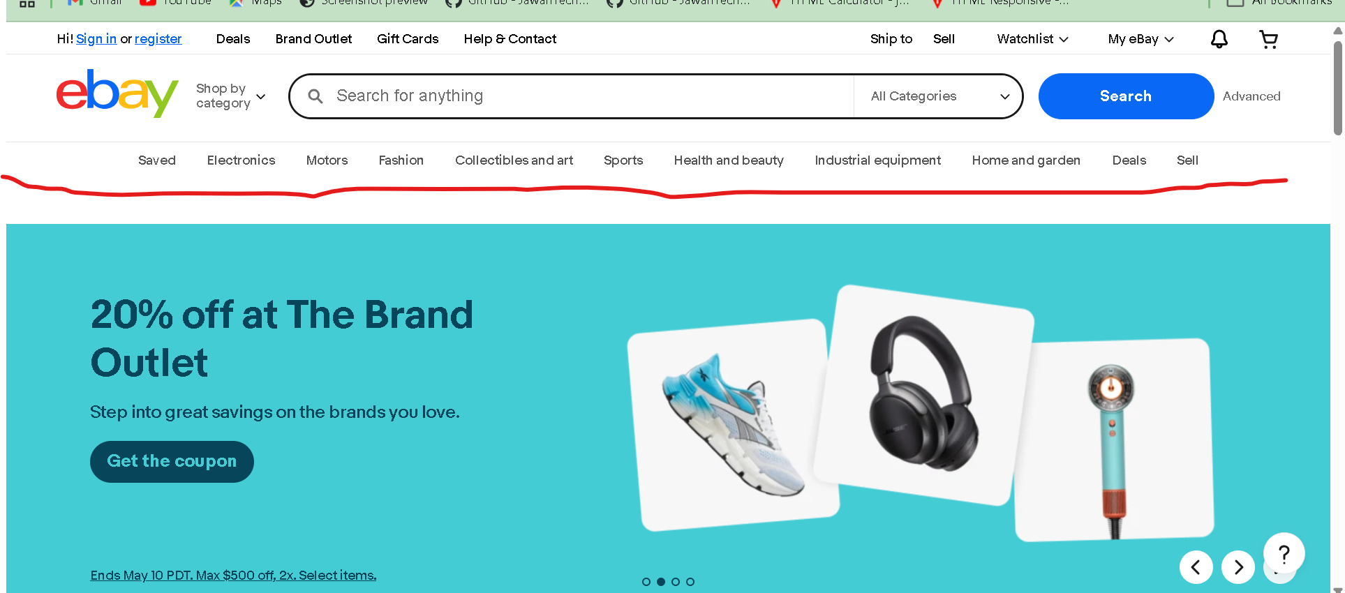

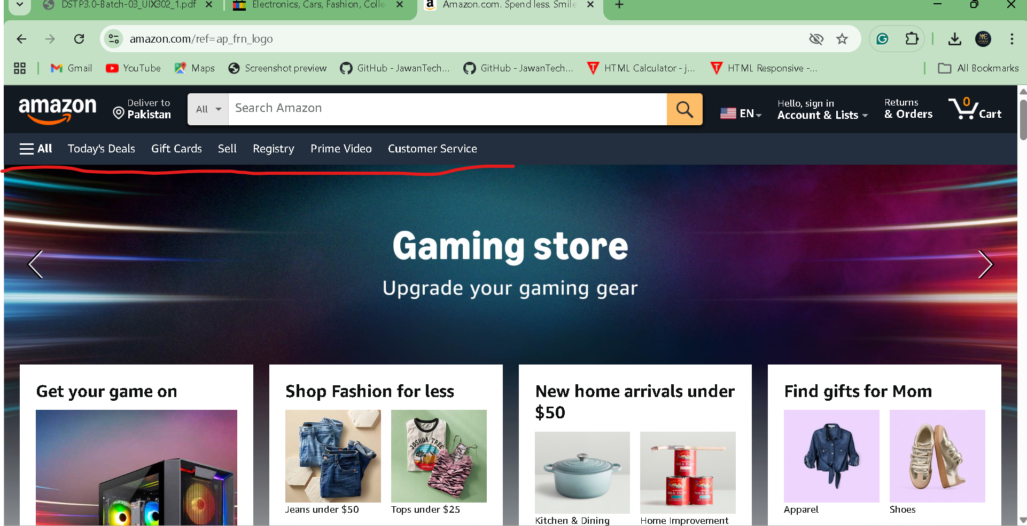

I liked the ebay’s Navbar more than amazon

- Add to Cart Buttons

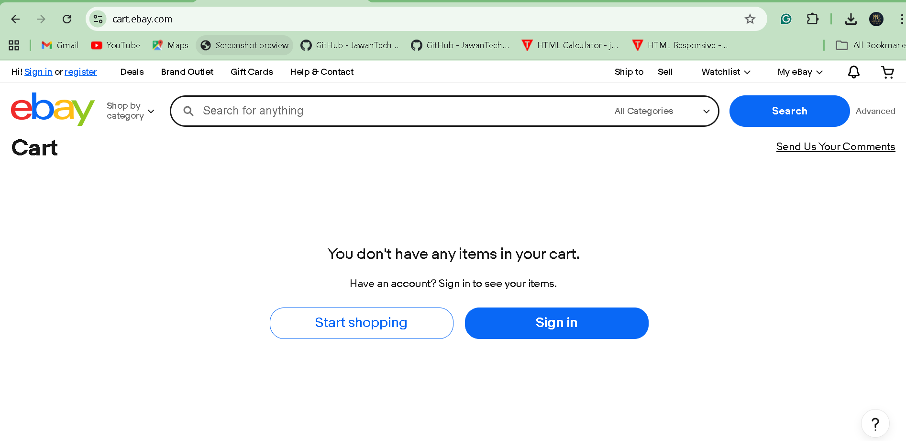

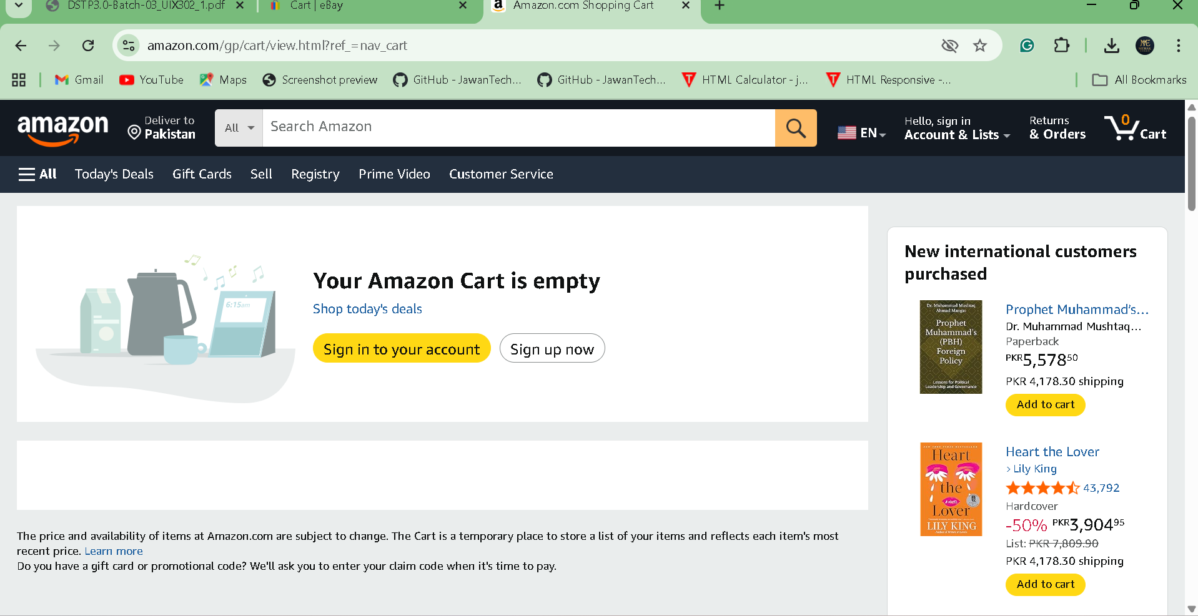

Frankly, I liked amazon’s Cart’s logo

- Checkout Flow

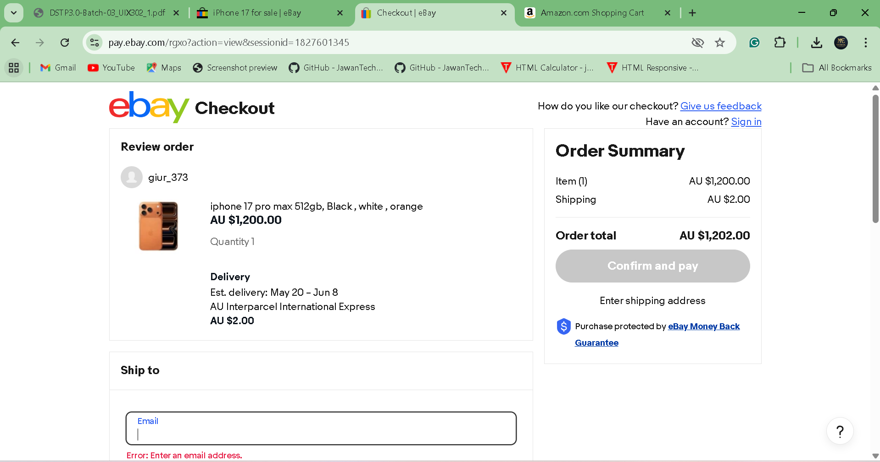

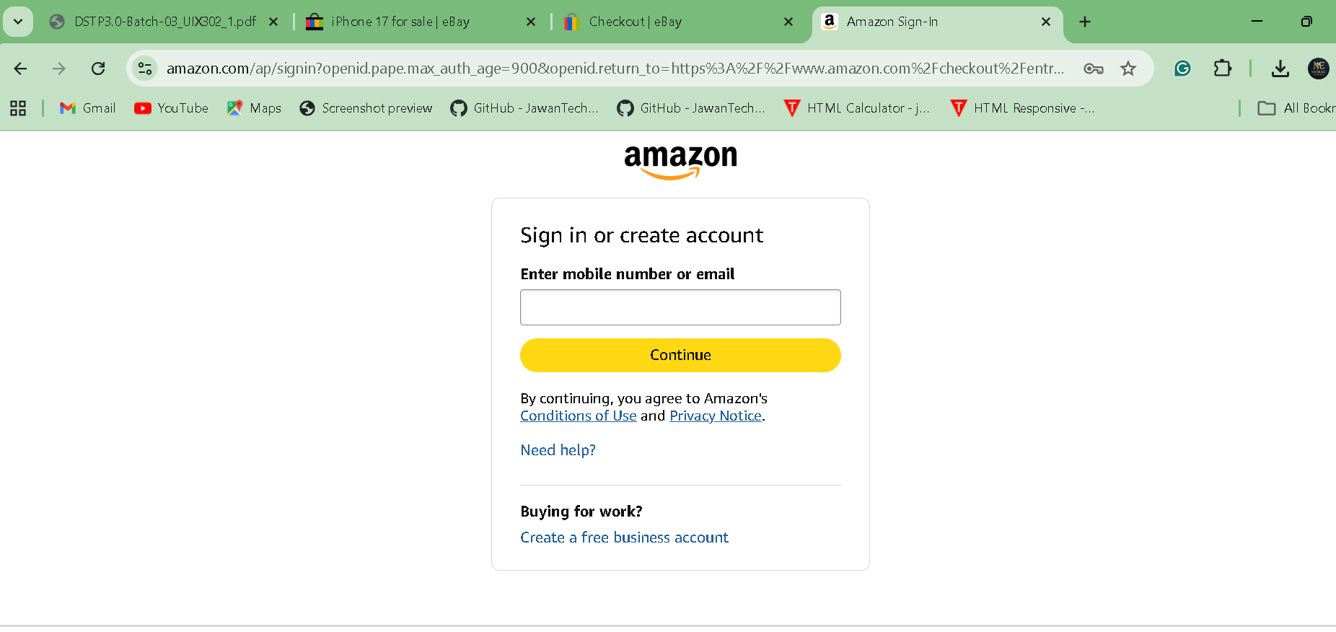
The ebay allowed me to buy as a guest where as amazon requires a sign up/sign in, so ebay is more easy going than amazon.

